**NEW APPLICATION (General Application)**

**Project Details -> Final Product Table:**

Final Product:

* Delete- On clicking Delete, it displays, Application Number and Record Id. Need to HIDE. Delete Message needs to be changed.

**Energy/Water Requirement**

* “Will the activity required Excavated muck disposal dumpyard” Selected (Yes)

Dump yard tables- DELETE not working

* “Will the activity require water consumption?” selected (Yes)

Raw Materials tables- DELETE not working

**Ancillary: Approach Road**

* “Will the activity require construction of Approach road?” (Yes),

Road Chainage table “EDIT” Not working

* Not able to click/Open the (Ancillary: Approach Road) tab after moving next to (Ancillary: Power Lines)
* Not able to Save & Next if selected **No** for Will the activity require construction of Approach road?

**Ancillary: Power Lines**

* If selected Yes, (Add Power Line Details)
* Transmission Line Chainage table “DELETE” Not working
* Not able to Save & Next if selected No for Will the activity require construction of Power Line?

Application Project Location selected under Bumthang Dzongkhag. (Bumthang Dzongkhag code is 1)

Competent Authority Id for Dzongkhag code 1(Bumthang) is 3.

ca_authority field in TABLES t_workflow_dtls and ec_industries_t1_general getting value 1. Which should be 3.

**Draft Application:**

**Project Details**

* No of Workers to be employed- is not showing the value.
* Final Products details (Project Details) not showing.
* While adding the final product, application number is not getting saved in the db. Edit product not working

**Energy and Water Requirement**

* Need to check the function. Not working.

**Ancillary Approach Road**

* Need to check the function. Not working.

**Ancillary Others**

* No option to select the ancillary

**File Attachment**

* After adding the file, Other files which were added for other application also displayed.

Need to add LOADER on submission

**Resubmit APPLICATION (General Application)**

* Additional information Letter section. Need file attachment options with Additional Information Text field.
* Reviewer’s remarks not displayed at Reviewer’s view details. Can only view Proponent’s remarks.
* Reviewer not able to proceed. No option available. NEED TO CHECK.

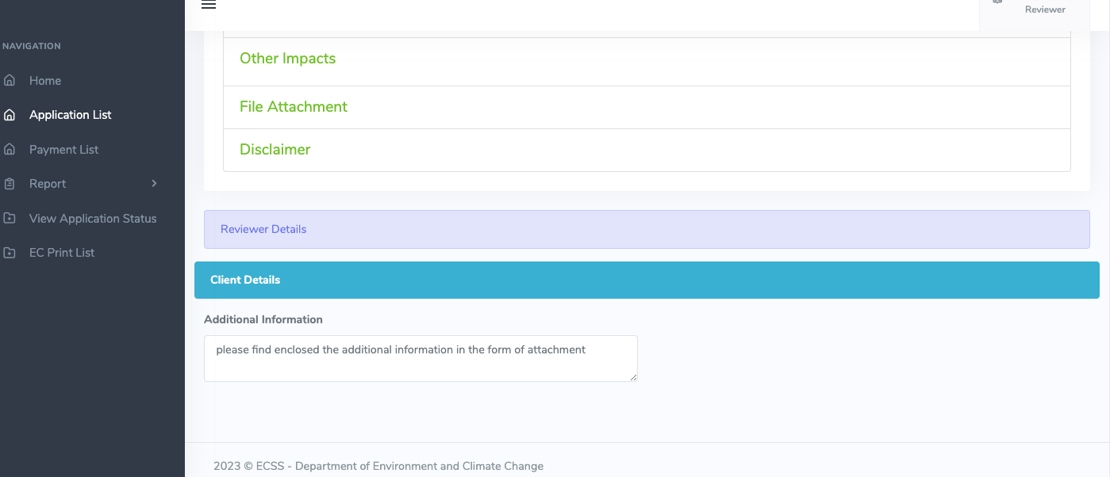

**Verifier’s Desk**

**Application List**

* While viewing the application,

Final Products details (Project Details) not showing. Instead **Abstraction Type** and other details (which were not entered) is being reflected.

Energy/Water Requirement -> disposal dumpyard (t_industries_t13_dubpyard) details not showing.

* Ancillary Approach Road details not showing
* Ancillary Power Lines details not showing
* Noise Level Tab is disabled. Not able to click.
* File attachment not reflected.

**Verifier’s Desk**

**Application List**

* While viewing the application,

Final Products details (Project Details) not showing. Instead **Abstraction Type** and other details (which were not entered) is being reflected.

Energy/Water Requirement -> disposal dumpyard (t_industries_t13_dubpyard) details not showing.

* Ancillary Approach Road details not showing
* Ancillary Power Lines details not showing
* Noise Level Tab is disabled. Not able to click.
* File attachment not reflected.
* Additional Information Letter, text entered by Verifier not getting saved. Same text entered by Reviewer is visible at the Proponent.